Image segmentation experiments

This section presents the comparative study of the clustering algorithms for image segmentation tasks. Eight images from the Berkeley benchmark Segmentation Dataset were selected for the experiment [1]. The performance of each of the algorithms was evaluated using normalized mutual info score, mean squared error, adjusted rand score, mean squared error [2]. The numerical segmentation results are presented in table 1 and Figure 1 depicts the graphical representation of the segmentation outputs.

Table image segmentation results

|  |  |  |  |  |  |  |  |  |  |
| --- | --- | --- | --- | --- | --- | --- | --- | --- | --- |
|  | Normalized mutual info score | | | Adjusted rand score | | | Mean squared error | | |
| Kmeans | FCM | POCS | Kmeans | FCM | POCS | Kmeans | FCM | POCS |
| image1 | 0.3151 | 0.2003 | 0.2573 | 0.2002 | 0.3058 | 0.2846 | 14490 | 15550 | 11626 |
| image2 | 0.2791 | 0.2469 | 0.3024 | 0.2534 | 0.2737 | 0.234 | 9732.6 | 9691.8 | 11310.8 |
| image3 | 0.5666 | 0.7136 | 0.6132 | 0.7284 | 0.5594 | 0.8142 | 2634.8 | 2742.5 | 2196.5 |
| image4 | 0.8081 | 0.5832 | 0.7744 | 0.891 | 0.6183 | 0.8667 | 1738.4 | 2266 | 1997.5 |
| image5 | 0.1484 | 0.1568 | 0.1623 | 0.1538 | 0.1542 | 0.1598 | 17496 | 17391 | 17223 |
| image6 | 0.6366 | 0.7865 | 0.641 | 0.7845 | 0.6393 | 0.7878 | 3337.6 | 3300.9 | 3276.9 |
| image7 | 0.4542 | 0.644 | 0.4515 | 0.6447 | 0.4533 | 0.6426 | 5097.1 | 5097.9 | 5028.5 |
| image8 | 0.6321 | 0.674 | 0.5985 | 0.674 | 0.6321 | 0.6283 | 5794.5 | 5794.5 | 6719.3 |

Figure Image segmentation result [ original, ground truth, kmeans output, FCM output, POCS output]

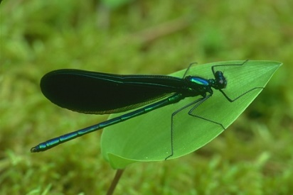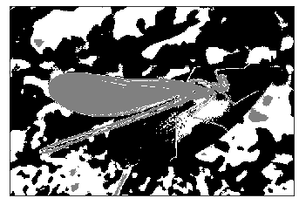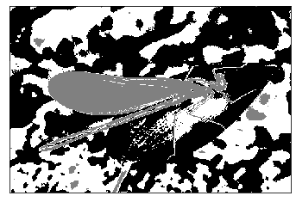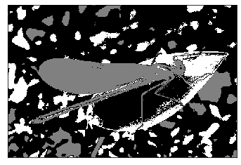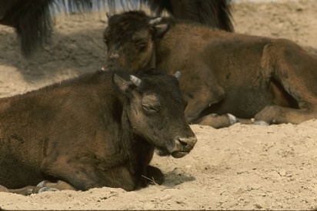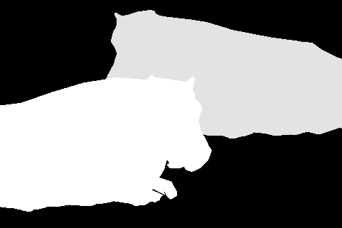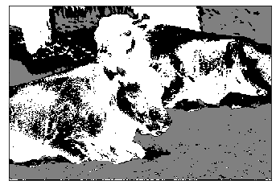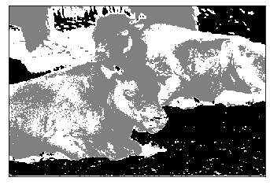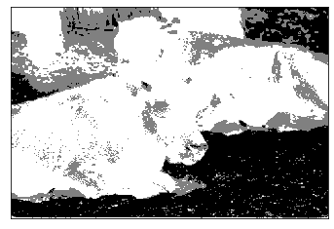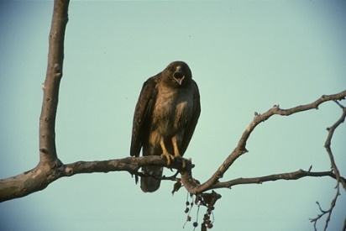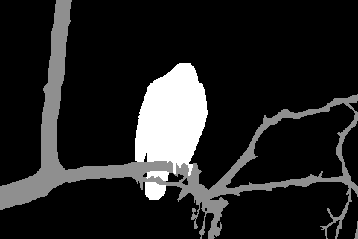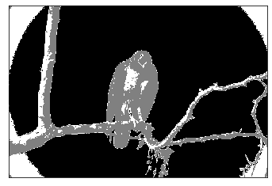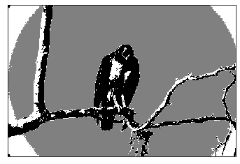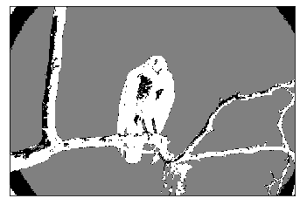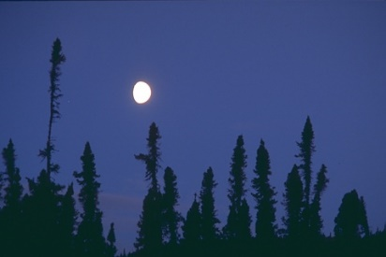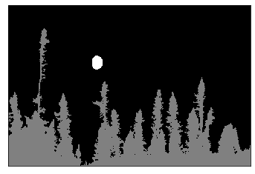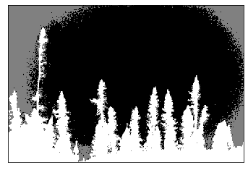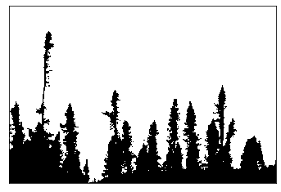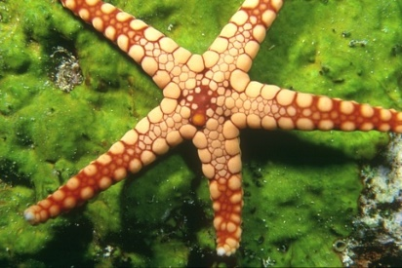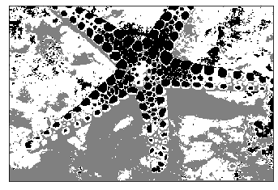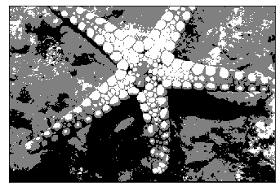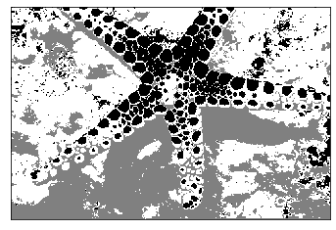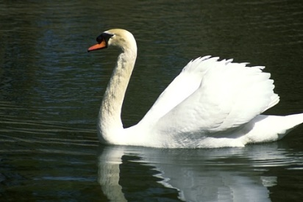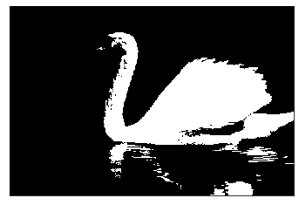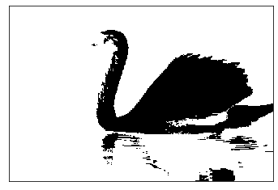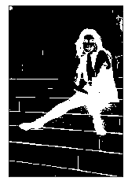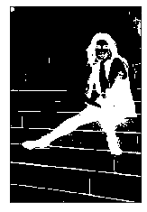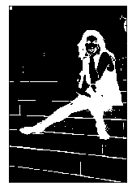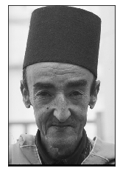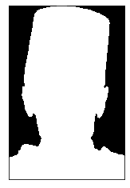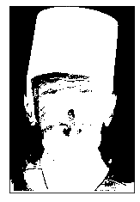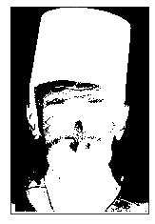

Reference

1. <https://www2.eecs.berkeley.edu/Research/Projects/CS/vision/bsds/>
2. Casper, W. R., and Balu Nadiga. "A new spectral clustering algorithm." *arXiv preprint arXiv:1710.02756* (2017).